HOW DOCKER COMPOSE IS WORKING

--------------------------------------------------------------------

**Directory Structure**

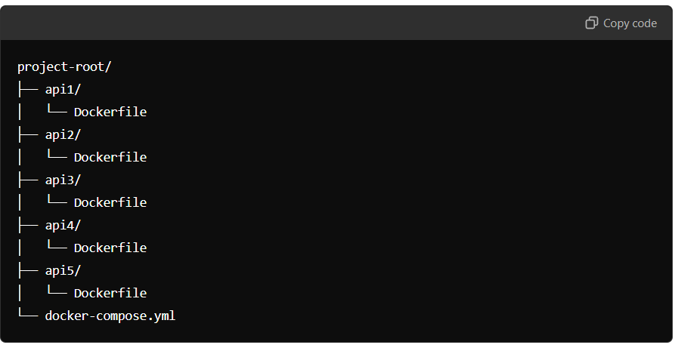

**Dockerfile for Each API**

In each API directory, write a Dockerfile. This file defines how the Docker image for that API will be built. A simple Node.js API Dockerfile might look like this:

# Use an official Node.js runtime as a base image

FROM node:18

# Set the working directory

WORKDIR /usr/src/app

# Copy package.json and package-lock.json

COPY package*.json ./

# Install the dependencies

RUN npm install

# Copy the rest of the application code

COPY . .

# Expose the application port

EXPOSE 3000

# Run the application

CMD ["npm", "start"]

Each API can have a slightly different Dockerfile depending on the technology stack used.

**docker-compose.yml File**

version: '3.8'

services:

api1:

build: ./api1

ports:

- "3001:3000"

networks:

- my-network

api2:

build: ./api2

ports:

- "3002:3000"

networks:

- my-network

api3:

build: ./api3

ports:

- "3003:3000"

networks:

- my-network

api4:

build: ./api4

ports:

- "3004:3000"

networks:

- my-network

api5:

build: ./api5

ports:

- "3005:3000"

networks:

- my-network

networks:

my-network:

driver: bridge

Explanation of docker-compose.yml:

• **version: '3.8'**: Specifies the Compose file format version.

• **services**: Each service corresponds to one of the APIs (api1, api2, etc.).

• **build**: Points to the directory where the Dockerfile for each API is located.

• **ports**: Maps the container's port to a port on the host (e.g., 3001:3000 maps port 3000 in the container to port 3001 on the host).

• **networks**: Defines a network for communication between the services (they'll be able to communicate internally).

**Build and Run the Docker Compose Setup:**

docker-compose build

docker-compose up

**Accessing the APIs**

Each API will be accessible via its respective port:

* API 1: http://localhost:3001
* API 2: http://localhost:3002
* API 3: http://localhost:3003
* API 4: http://localhost:3004
* API 5: http://localhost:3005

**Stopping the Containers**

docker-compose down